Wyoming Minor Ball
Board Meeting Agenda
December 6, 2018
6:30 PM, Wyoming Legion
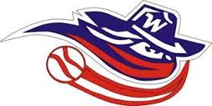

- Roll Call
- Minutes
- Treasurers Report, Lana Mullins
- Registrars Report, Lyndsey King
- On-Going Business
  - Wranglers President
  - Concession Manager
  - Donor recognition Bricks
  - Update from Plympton-Wyoming Parks Board Meeting, Brian Helps
  - Update of Southpoint Equipment sponsorship, Chad Turnbull
  - Water Fill Stations, Mandi Pearson
  - John Knox Diamond maintenance
  - Diamond Inventory (available parks, schools, etc…)
  - Awards Night
- Round Table
  - Trivia Night update, Craig Steadman
- Next Meeting
- Adjournment

